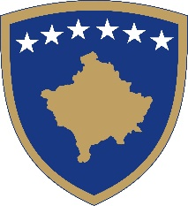 | Republika e Kosovës  Republika Kosova - Republic of Kosovo  Agjencia e Kosovës për Akreditim  Agencija Kosova za Akreditaciju  Kosovo Accreditation Agency

Kosovo Accreditation Agency (KAA) presents the activities of the KAA for 2021 and the KAA Strategy 2021-2025.
The meeting will be held at the Sirius Hotel in Prishtina, on Tuesday, 25.01.2022.

Agenda

10:30 – 11:00 Registration of participants.
11:00 – 11:30 Opening remarks:
- President of the State Council of Quality (SCQ), prof. Hasnija Ilazi;
- Prime Minister, Mr. Albin Kurti;
- Minister of Education, Science, Technology and Innovation (MESTI), Ms. Arbërie Nagavci;
- Chairperson of the Parliamentary Committee on Education, Science, Technology, Innovation, Culture and Sport, Mr. Ardian Gola;
- Deputy Head of the European Office in Kosovo and Head of Political Section, Ms. AnnaCarin Platon.
11:30 – 12:00 Presentation of KAA activities for 2021 and KAA Strategy 2021-2025 by the Director of the Kosovo Accreditation Agency (KAA), Mr. Naim Gashi.
12:00 – 13:00 Drinks and snacks.

NOTE:
All anti-Covid measures will be respected in accordance with the recommendations of the NIPHK and the Ministry of Health.

